The Church at Worship
*Those who are able are invited to stand.
Congregational responses and unison readings are indicated in bold.

The Gathering

WELCOME AND ANNOUNCEMENTS

PRELUDE

PRAYER OF THE DAY

God who gathers us, on this Pentecost Sunday, in this season of the Spirit and the first signs of summer, grant us the courage of a planted seed, poised for growth, ready to burst from the dark, rich soil of Word and Worship. May the timing of our growth coincide with your created order. May we bloom in righteousness as the sun rises high and the crops grow tall. Let us hear with anticipation, the winds of the Holy Spirit this morning, now, and always. In Jesus’ holy name, Amen.

CALL TO WORSHIP (based on Acts 2:1-4)

Leader: | All together in one place;
People: | they heard the rush of a violent wind;
Leader: | It filled the entire house.
People: | Divided tongues, as of fire, appeared and rested on each of them;
ALL: | They were filled with the Holy Spirit.

*HYMN OF PRAISE Jesus, Name Above All Names # 57

CALL TO CONFESSION

God’s Spirit has gathered us for worship. Let us confess our sins and return to God.

PRAYER OF CONFESSION

Spirit of God, we hesitate and doubt. You call us to act boldly but our fear keeps us from following your call. Forgive our lack of courage. Embolden us to dream big and trust the Spirit to fill us and use us. Help us be Christ’s church without hesitation. Guided by your Holy Spirit, help us usher in your kingdom to come. Amen.

(Moment for silent confession)

ASSURANCE OF PARDON (from Acts 2:21)

Leader: | “Everyone who calls on the name of the Lord shall be saved.” In Jesus Christ, we are forgiven and freed. Amen.
All: | Thanks be to God, Amen.

The Response to Forgiveness

*Gloria Patri #620

THE PEACE OF CHRIST

One: | The peace of the Lord Jesus Christ which passes all understanding be with you all.
All: | And also with you.
(Please turn to those around you and extend the hand of peace and friendship)

*HYMN OF RESPONSE Be Thou My Vision # 400

The Word

SCRIPTURE Ezekiel 37:1-4 & Psalms 104:24-34

SERMON Shake, Rattle, and Roll
Re Louan Pyron

The Response
AFFIRMATION OF FAITH Apostle’s Creed
I believe in God the Father Almighty, Maker of heaven and earth.
And in Jesus Christ His only Son our Lord, who was conceived by
the Holy Ghost, born of the Virgin Mary, suffered under Pontius Pilate, was crucified, dead and buried; He descended into hell; the third day He rose again from the dead; He ascended into heaven, and sitteth on the right hand of God the Father Almighty; from thence He shall come to judge the quick and the dead.

I believe in the Holy Ghost; the holy catholic church; the communion of saints; the forgiveness of sins; the resurrection of the body; and the life everlasting. Amen.

The Eucharist

PRAYERS OF THE PEOPLE AND THE LORD’S PRAYER

PRESENTATION OF TITHES AND OFFERINGS

*DOXOLOGY # 623

Praise God from whom all blessings flow;
Praise God all people here below;
Praise God above ye heavenly host;
Praise Father; Son and Holy Ghost. Amen.

*PRAYER OF DEDICATION

The Sending

*CLOSING HYMN The Family of God # 128

*CHARGE AND BENEDICTION

*CHORAL RESPONSE God Be With You #583

POSTLUDE

Congregational Care

Irene Booth, aunt of Louan Pyron; Rosemary Harris and her helper Linda; Ethan, friend of Nebe; Alex Lanphear; Lee Franklin Laster & wife, Darlene; Emma Lollar; Jan Pennington; Terry Thomas, the Rev. Tracy Williams; those unable to attend church and those serving in the military, as missionaries and in works of mercy and relief around the world and their families.

Address for Emma Lollar:

Emma Lollar
PSC 9 Box 884 APO, AE
09123

What is the Origin of Pentecost?

Pentecost was the celebration of the beginning of the early weeks of harvest. In Palestine, there were two harvests each year. The early harvest came during the months of May and June; the final harvest came in the Fall. Pentecost was the celebration of the beginning of the early wheat harvest, which meant that Pentecost always fell sometime during the middle of the month of May or sometimes in early June.

There were several festivals, celebrations, or observances that took place before Pentecost. There was Passover, there was Unleavened Bread, and there was the Feast of Firstfruits. The Feast of Firstfruits was the celebration of the beginning of the barley harvest. Here's the way you figured out the date of Pentecost.

According to the Old Testament, you would go to the day of the celebration of Firstfruits, and beginning with that day, you would count off 50 days. The fiftieth day would be the Day of Pentecost. So Firstfruits is the beginning of the barley harvest and Pentecost is the celebration of the beginning of the wheat harvest.

Modern Christians observe Pentecost as a holiday, not to celebrate a wheat harvest, but to remember when the Holy Spirit invaded the Church in Acts 2.

On Pentecost Sunday, the Holy Spirit filled the Church with power and added 3,000 new believers. The account in Act 2 reports that, after Jesus ascended into heaven, Jesus’ followers were gathered together for the Feast of Harvest (aka Pentecost), and the Holy Spirit “filled the whole house where they were sitting” (Acts 2:2). “All of them were filled with the Holy Spirit and began to speak in other tongues as the Spirit enabled them” (Acts 2:4).

This strange occurrence drew a large crowd, and Peter stood up to speak to them about repentance and the gospel of Christ (Acts 2:14). By the end of the day that the Holy Spirit came, the Church grew by 3,000 people (Acts 2:41). This is why Christians still celebrate Pentecost.

The Leadership of the Church

SESSION serves as the governing council of the church.

Current members of the Session are:
The Rev. Ron Jones, Moderator
Louan Pyron, Clerk
Cindy Lanphear, Treasurer

Class of 2024 | Class of 2025 |  | Class of 2026
Linda McDougal |  | Stephen Fyr |  | Louan Pyron
Chris Lanphear | Ann Pfeifler |  | Maribeth Laster

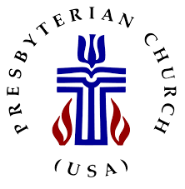
NOTES FROM TODAY’S LESSONS

HARMONY PRESBYTERIAN CHURCH

Established 1844

A Member Congregation of the Presbyterian Church (USA)
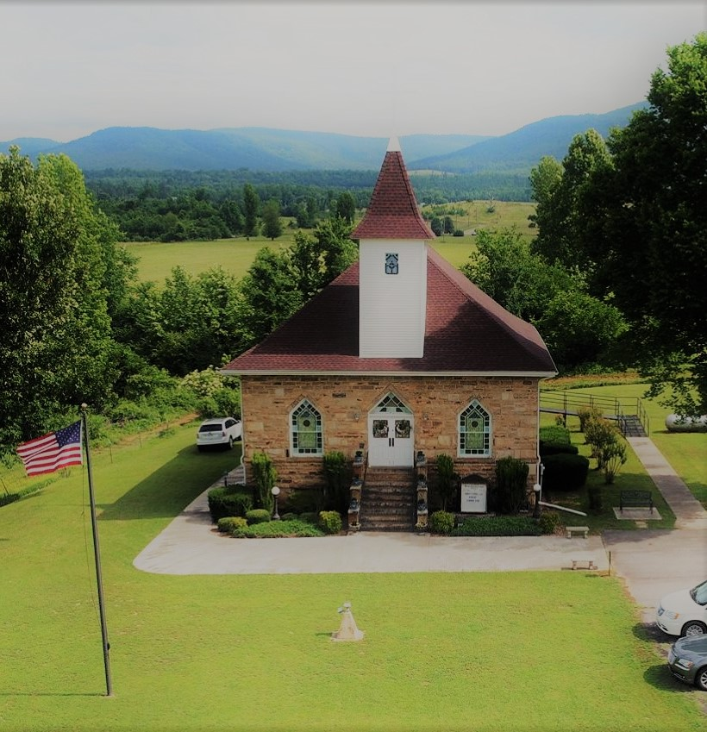
Day of Pentecost

May 19, 2024

Worship 10:00 a.m.

